# Create and activate an isolated environment
python3 -m venv .venv
source .venv/bin/activate

# Install dependencies
python -m pip install -r requirements.txt

# Download and inspect data
python scripts/download_data.py
python scripts/eda.py

# Prepare the train-test split
python scripts/prepare_data.py

# Train, tune and evaluate
python scripts/train_models.py
python scripts/tune_models.py
python scripts/evaluate_model.py

# Verify the saved model
python scripts/verify_model.py

Task 1: Data Acquisition and Exploratory Data Analysis
Objective
Acquire the Heart Disease UCI dataset, inspect its quality, and explore its characteristics before model development.
1. Environment and data acquisition
A dedicated Python 3.12 virtual environment was created for the project. Packages installed for data acquisition, analysis, visualization, and modelling included ucimlrepo, pandas, NumPy, matplotlib, seaborn, and scikit-learn. Installed versions were recorded in requirements.txt to support reproducibility.
The dataset was downloaded programmatically using:
dataset = fetch_ucirepo(id=45)
The 13 input features and original target column, num, were combined into a pandas DataFrame. The resulting dataset contained 303 patient records and 14 columns and was saved to data/raw/heart_disease.csv using scripts/download_data.py.
The raw dataset was retained without replacing missing values or modifying the original target.
2. Data inspection and quality checks
The scripts/eda.py script examined the first five records, column data types, missing values, duplicate rows, and descriptive statistics.
Quality check | Result
Patient records | 303
Input features | 13
Original target | num
Missing values in ca | 4
Missing values in thal | 2
Missing values in other columns | 0
Duplicate rows | 0
Descriptive statistics included counts, means, standard deviations, minimums, maximums, and quartiles. For example, patient ages ranged from 29 to 77 years, with a mean of approximately 54.44 years.
Although all columns were stored numerically, several represented categories. These included chest-pain type (cp), resting ECG result (restecg), and thalassemia test category (thal). Their numeric codes should not automatically be treated as continuous measurements.
3. Target interpretation and class balance
For the binary classification objective, a temporary binary target was derived for analysis:
- 0: heart disease absent (num = 0).
- 1: heart disease present (num > 0).
The original CSV remained unchanged.
Binary class | Records | Percentage
Absent | 164 | 54.1%
Present | 139 | 45.9%
The dataset was reasonably balanced, so substantial class imbalance was not identified at this stage.
4. EDA visualizations
Three visualizations were generated and saved in reports/figures:
File | Purpose
class_balance.png | Compare the number of patients in each binary class
feature_histograms.png | Inspect distributions of age, resting blood pressure, cholesterol, maximum heart rate, and ST depression
correlation_heatmap.png | Examine Pearson correlations among continuous features and the binary target
Histograms were used to support inspection of feature ranges, skewness, and possible extreme values. The correlation heatmap excluded categorical codes to avoid misleading interpretations of their numerical labels. The original num column was also excluded from the heatmap and replaced with the binary target.
Correlation was interpreted as association, rather than evidence of causation. No specific correlation coefficients or outlier-removal decisions are reported here without reviewing the generated plots.
5. Preprocessing decisions and remaining work
No duplicate removal was required. Missing values were identified in ca and thal, but imputation has not yet been performed.
Missing-value handling, categorical encoding, and numerical scaling will be implemented within the model pipeline. These transformations will be fitted only on training data—and within each cross-validation fold—to prevent information leakage.
Task 1 has therefore established the dataset source, reproducible acquisition process, quality findings, and EDA figures. The cleaning/preprocessing implementation and its verification remain to be completed alongside Task 2.

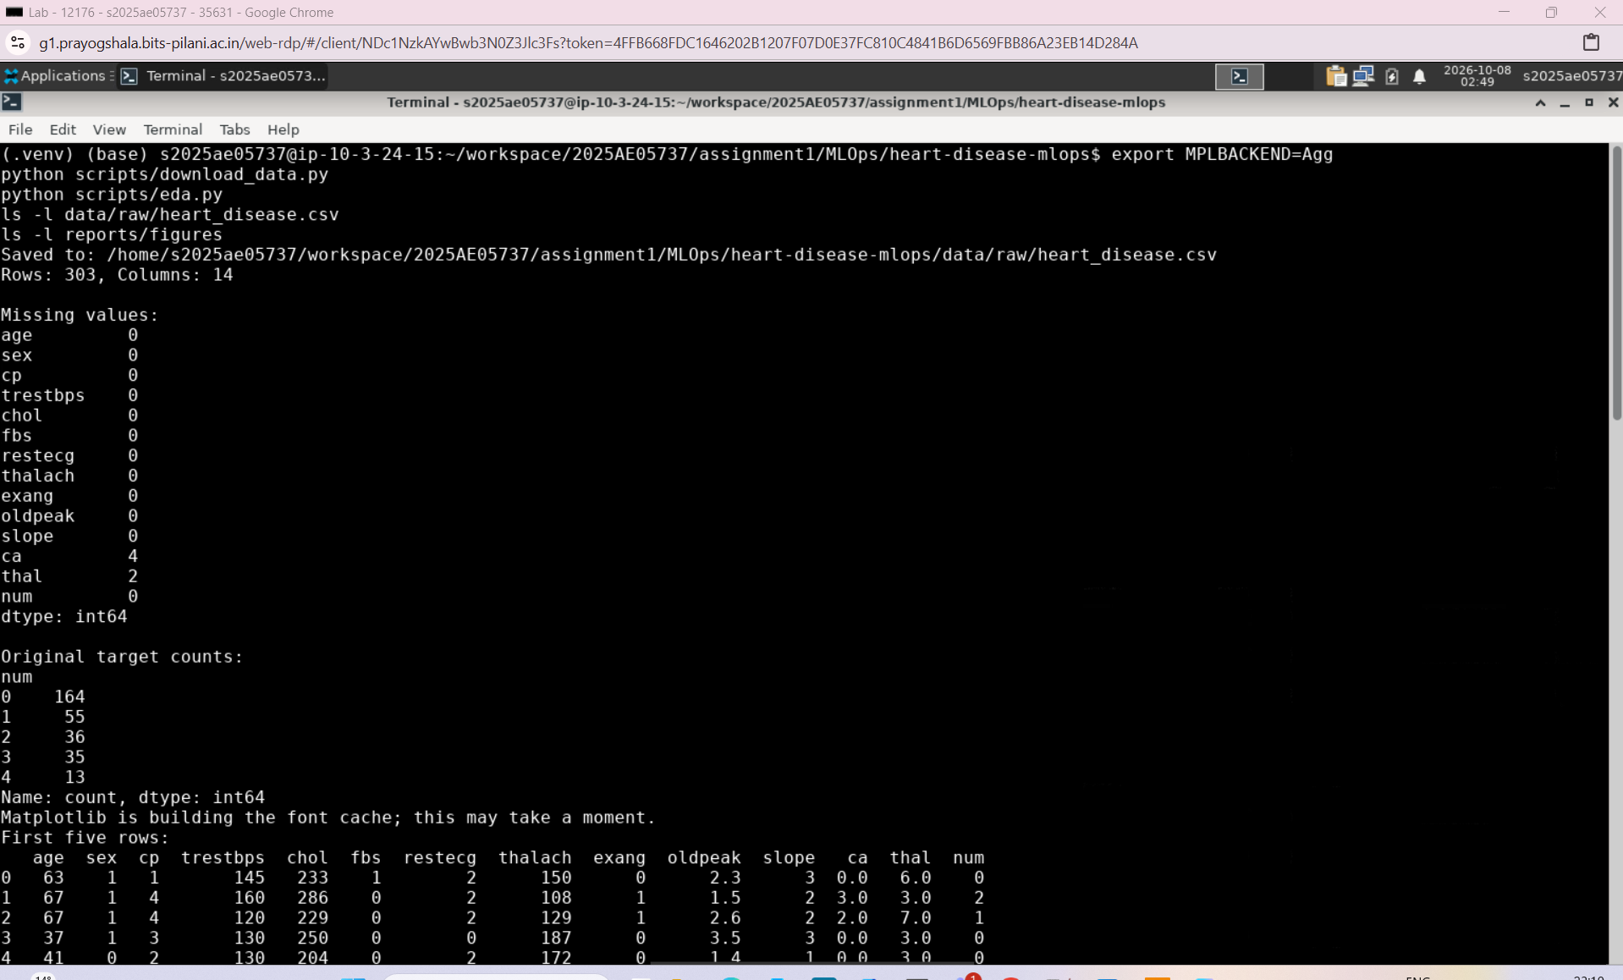

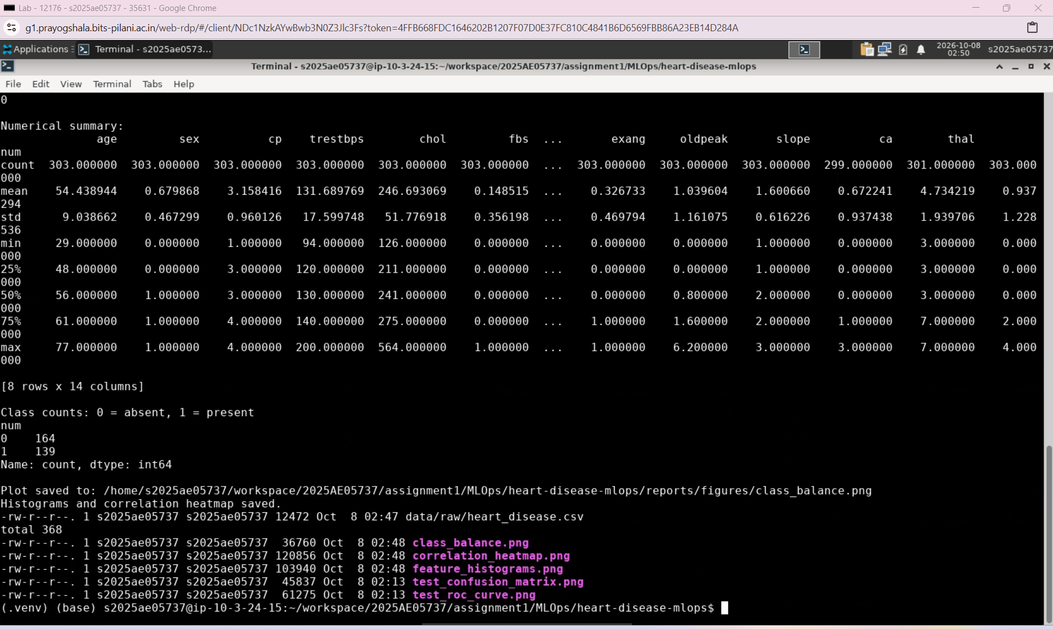

Task 2 / Part B: Feature Engineering and Model Development
Objective
Develop and compare two heart disease classifiers using reproducible preprocessing, cross-validation, and hyperparameter tuning. Select a model using training-data validation results, then evaluate it on a separate held-out test set.
1. Target preparation and data splitting
The original target column, num, was converted into a binary label:
- 0 — Heart disease absent: original num = 0.
- 1 — Heart disease present: original num values of 1–4.
The original num column was excluded from the input features to prevent target leakage.
Using prepare_data.py, the 303 records were divided into 242 training records (80%) and 61 test records (20%). Stratification preserved approximately the same class proportions in both sets. A fixed random_state=42 made the split reproducible.
The datasets were saved as data/processed/train.csv and data/processed/test.csv. These files contain the split data; missing values are handled later by the model pipeline.
2. Feature engineering and preprocessing
A reusable preprocessing function was implemented in preprocessing.py using scikit-learn’s Pipeline and ColumnTransformer.
Feature group | Columns | Treatment
Continuous measurements | age, trestbps, chol, thalach, oldpeak | Median imputation followed by standard scaling
Categorical features | sex, cp, fbs, restecg, exang, slope, ca, thal | Most-frequent imputation followed by one-hot encoding
For this implementation, ca and slope were treated as categorical features. All 13 input features were retained.
One-hot encoding avoided treating category codes as continuous magnitudes. handle_unknown="ignore" allowed the encoder to transform previously unseen categories without raising an error.
Preprocessing was included inside each classifier’s pipeline. Consequently, imputation values, scaling statistics, and encoding categories were learned only from the training portion of each cross-validation fold.
3. Baseline model comparison
Two classifiers were evaluated in train_models.py:
- Logistic Regression: a regularized linear baseline.
- Random Forest: an ensemble capable of capturing nonlinear relationships and interactions.
Five-fold stratified cross-validation was performed on the training set, with shuffling and random_state=42. Accuracy, precision, recall, and ROC-AUC were recorded.
Baseline model | Accuracy | Precision | Recall | ROC-AUC | AUC standard deviation
Logistic Regression | 84.71% | 87.68% | 78.34% | 0.9025 | 0.0144
Random Forest | 81.39% | 81.29% | 77.39% | 0.8927 | 0.0329
Logistic Regression achieved higher baseline mean scores across all four metrics and lower variation in ROC-AUC across folds.
The results were saved to reports/baseline_cv_results.csv.
4. Hyperparameter tuning
Both models were tuned using GridSearchCV in tune_models.py. The search used the same five-fold stratified cross-validation approach and selected configurations by mean validation ROC-AUC.
Model | Parameters explored
Logistic Regression | C: 0.01, 0.1, 1, 10; class weighting: none or balanced
Random Forest | Maximum depth: unrestricted, 5, 10; minimum samples per leaf: 1, 3, 5; class weighting: none or balanced
Random Forest used 200 trees. The search evaluated 8 Logistic Regression configurations and 18 Random Forest configurations.
The best configurations were:
- Logistic Regression: C=0.1, class_weight="balanced".
- Random Forest: max_depth=5, min_samples_leaf=3, class_weight="balanced".
Tuned model | Accuracy | Precision | Recall | ROC-AUC
Logistic Regression | 83.04% | 82.32% | 80.99% | 0.9028
Random Forest | 79.74% | 78.60% | 77.35% | 0.9040
Full search results were saved to logistic_regression_tuning.csv and random_forest_tuning.csv, with the comparison saved to tuned_cv_results.csv under reports.
5. Model selection and packaging
Random Forest was selected because it achieved the highest mean cross-validation ROC-AUC, the predefined selection metric.
Its AUC advantage was small—approximately 0.0013—while tuned Logistic Regression achieved better accuracy, precision, and recall at the default classification threshold. The selection therefore reflects the chosen metric, rather than evidence that Random Forest is superior on every measure.
The selected configuration was refitted on all 242 training records. Its fitted preprocessing and classifier were saved together as:
models/model.joblib
Saving the complete pipeline ensures that prediction uses the same preprocessing learned during training.
6. Held-out test evaluation
The saved pipeline was evaluated using evaluate_model.py on the 61 test records. The test set was not used for hyperparameter tuning or model selection.
Metric | Held-out test result
Accuracy | 88.52%
Precision | 83.87%
Recall | 92.86%
ROC-AUC | 0.9556
The predictions corresponded to:
Outcome | Patients
True positives: disease correctly detected | 26
False negatives: disease missed | 2
True negatives: absence correctly identified | 28
False positives: absence incorrectly flagged | 5
Test metrics were saved to reports/test_metrics.json. The confusion matrix and ROC curve were saved as test_confusion_matrix.png and test_roc_curve.png under reports/figures.
7. Outcome and limitations
This task produced a reproducible train/test split, a reusable preprocessing pipeline, two baseline classifiers, documented hyperparameter searches, and a selected model evaluated on held-out data.
The test scores exceeded the cross-validation averages, which can occur with a small test sample. Both sets of results should be reported. The dataset and single held-out split do not establish clinical reliability; this model is an educational demonstration.
MLflow tracking has not yet been integrated. That work belongs to Task 3.
python scripts/prepare_data.py
python scripts/train_models.py
python scripts/tune_models.py
python scripts/evaluate_model.py

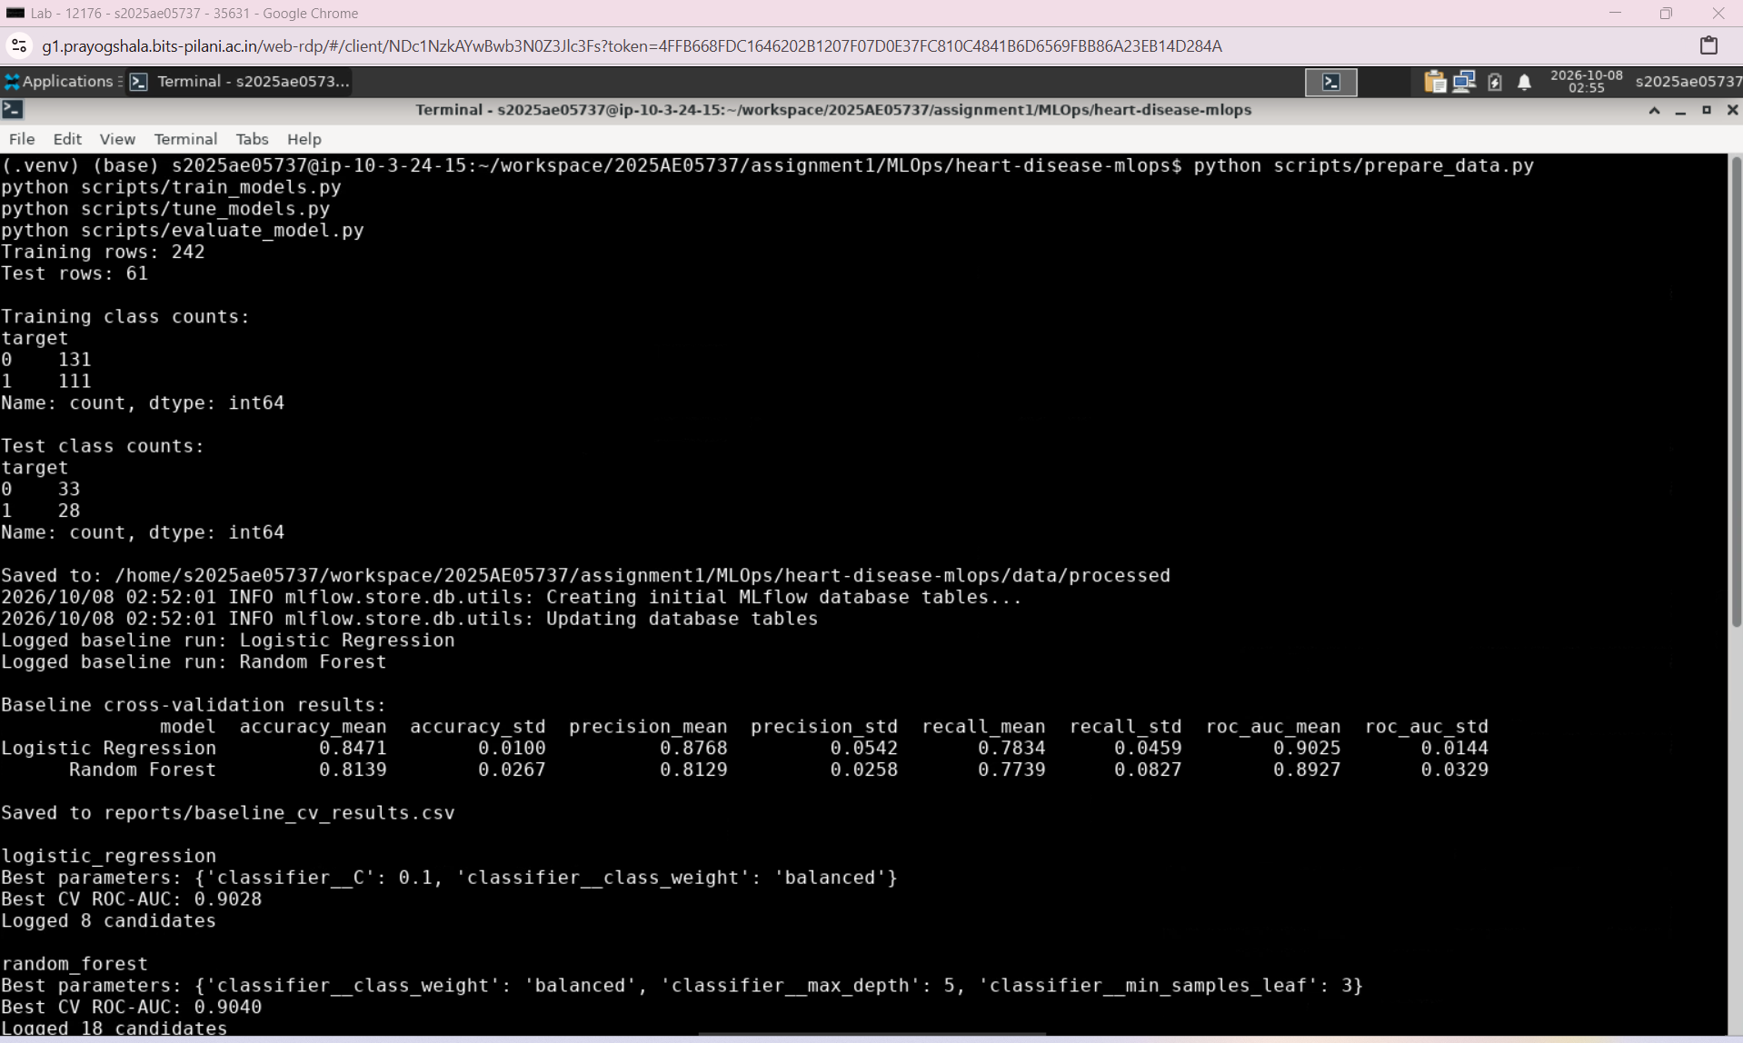
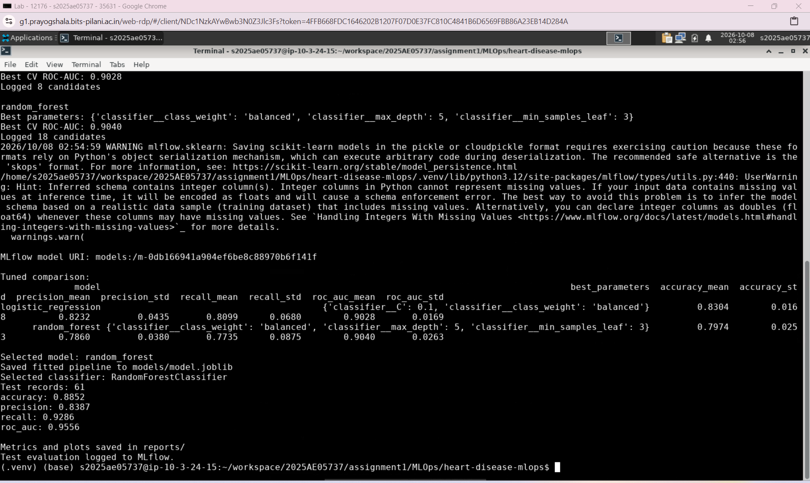

Step 3: Experiment Tracking with MLflow
Objective
The objective of this step was to record model experiments systematically, including their parameters, evaluation metrics, and generated artifacts. This allows us to compare experiments and inspect how the final model was selected.
3.1 MLflow Setup
We installed MLflow version 3.16.1 in the project’s virtual environment.
We created scripts/tracking.py to configure a shared tracking location for all scripts.
Component | Configuration
Experiment name | heart-disease-classification
Tracking database | mlflow.db
Artifact directory | mlartifacts/
Dashboard address | http://localhost:5000
The configuration resolves paths relative to the project root. This ensures that scripts use the same tracking database even when executed from different folders.
3.2 Baseline Model Tracking
We updated scripts/train_models.py to create separate MLflow runs for:
- Logistic Regression
- Random Forest
Each run records classifier parameters, preprocessing settings, training-record count, and cross-validation configuration.
We logged accuracy, precision, recall, and ROC-AUC for each fold, along with their means and standard deviations. Fold-level and summary CSV files were also stored as artifacts.
Baseline cross-validation results:
Model | Accuracy | Precision | Recall | ROC-AUC
Logistic Regression | 0.8471 | 0.8768 | 0.7834 | 0.9025
Random Forest | 0.8139 | 0.8129 | 0.7739 | 0.8927
Preprocessing remained inside each model pipeline and was fitted separately within each training fold to prevent data leakage.
3.3 Hyperparameter Tuning Tracking
We updated scripts/tune_models.py to record every parameter combination evaluated by GridSearchCV.
The search evaluated:
Model | Parameter combinations | CV folds
Logistic Regression | 8 | 5
Random Forest | 18 | 5
Total | 26
Each model has a parent tuning run, with individual parameter combinations recorded as nested candidate runs.
Each candidate logs:
- Fixed and tuned classifier parameters.
- Accuracy, precision, recall, and ROC-AUC means and standard deviations.
- Individual fold metrics.
- Its ranking according to cross-validation ROC-AUC.
The complete search results were saved locally and logged as CSV artifacts.
Best parameter settings:
Model | Best parameters
Logistic Regression | C=0.1, class_weight="balanced"
Random Forest | max_depth=5, min_samples_leaf=3, class_weight="balanced"
Tuned cross-validation results:
Model | Accuracy | Precision | Recall | ROC-AUC
Logistic Regression | 0.8304 | 0.8232 | 0.8099 | 0.9028
Random Forest | 0.7974 | 0.7860 | 0.7735 | 0.9040
Random Forest was selected because it achieved the highest mean cross-validation ROC-AUC. The difference was small, so the selection does not imply that Random Forest was better across every metric.
The held-out test dataset was not used for model selection.
3.4 Selected Model Logging
We created a separate selected_random_forest run containing:
- Selected classifier parameters.
- Cross-validation metrics.
- The tuned-model comparison report.
- The fitted pipeline as a joblib artifact.
- The pipeline in MLflow model format, including an input example and inferred schema.
The first logging attempt failed because the skops serializer rejected types within the Random Forest pipeline. We explicitly configured serialization_format="cloudpickle" and reran the script successfully.
The model was saved with the following MLflow URI:
models:/m-f179ffafa73d408bbf0574154694b497
3.5 Test Evaluation Tracking
We updated scripts/evaluate_model.py to record evaluation on 61 held-out test records.
The script loads the saved pipeline and evaluates it without retraining.
Test results:
Metric | Value
Accuracy | 0.8852
Precision | 0.8387
Recall | 0.9286
ROC-AUC | 0.9556
The evaluation run logs:
- Test metrics.
- Classifier parameters.
- Test-record count.
- A SHA-256 fingerprint identifying the evaluated model file.
- test_metrics.json.
- The confusion matrix.
- The ROC curve.
These results matched the earlier evaluation.
3.6 MLflow Dashboard
We started the dashboard from the project root using:
mlflow ui --backend-store-uri sqlite:///mlflow.db --host 127.0.0.1 --port 5000
The dashboard was opened successfully and used to inspect experiment runs, parameters, metrics, and artifacts.
Step 3 Outcome
Experiment tracking was implemented successfully. Baseline experiments, all 26 tuning candidates, the selected pipeline, and held-out test evaluation are recorded in MLflow.

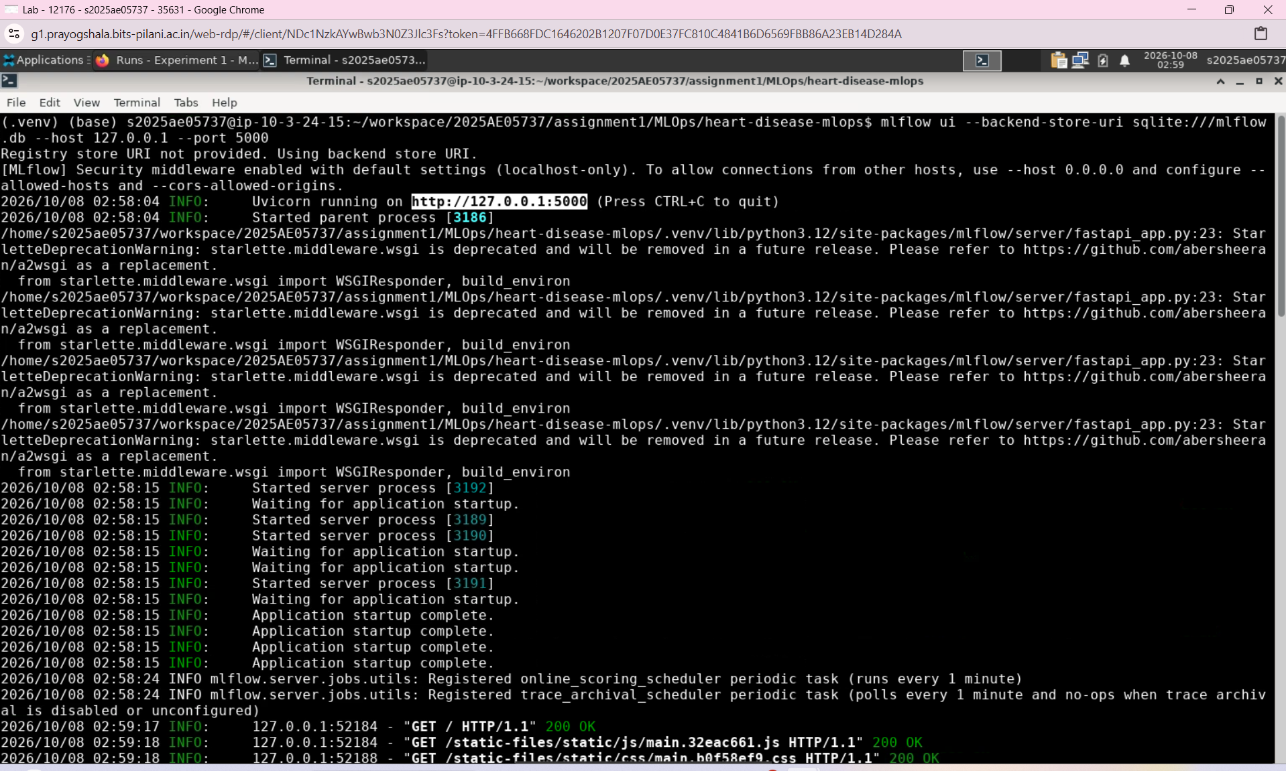

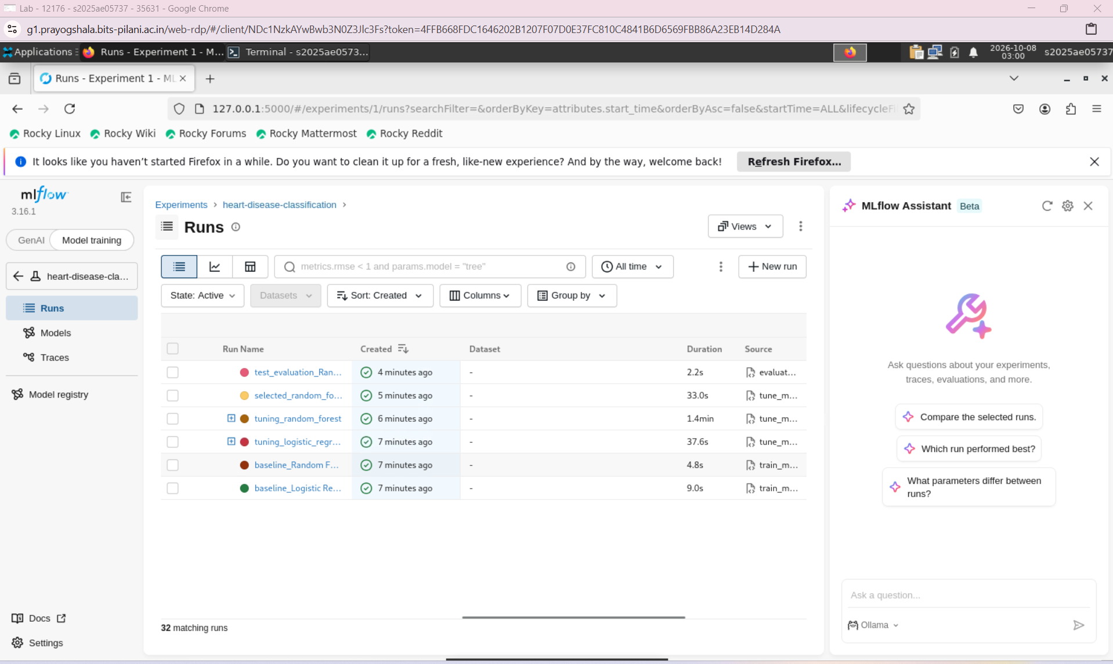

Step 4: Model Packaging and Reproducibility
Objective
The objective of this step was to package the trained model with its preprocessing, capture software dependencies, and verify that the saved pipeline can be loaded and used for predictions.
4.1 Packaging the Complete Pipeline
The selected model was saved as:
models/model.joblib
The artifact contains both fitted preprocessing and the trained classifier.
Component | Implementation
Numeric missing values | Median imputation
Numeric scaling | StandardScaler
Categorical missing values | Most-frequent imputation
Categorical encoding | OneHotEncoder(handle_unknown="ignore")
Classifier | Tuned RandomForestClassifier
The final Random Forest uses:
n_estimators = 200
max_depth = 5
min_samples_leaf = 3
class_weight = balanced
random_state = 42
GridSearchCV refitted the selected pipeline on all 242 training records before it was saved.
Packaging preprocessing with the classifier ensures that inference applies the same fitted transformations used during training.
4.2 Input Features
The pipeline accepts the original 13 input features.
Feature type | Features
Numeric | age, trestbps, chol, thalach, oldpeak
Categorical | sex, cp, fbs, restecg, exang, slope, ca, thal
The target is excluded from inference inputs.
The binary target represents:
- 0: Disease absent.
- 1: Disease present.
4.3 MLflow Model Packaging
The fitted pipeline was also saved in MLflow model format.
This package includes the model, an input example, an inferred input/output schema, and environment information generated by MLflow.
The local joblib file supports direct loading, while the MLflow model provides a tracked model package associated with the selected-model run.
4.4 Dependency Management
The project uses a Python virtual environment to isolate its dependencies.
The following command captures installed package versions in requirements.txt:
uv pip freeze > requirements.txt
These dependencies can be installed on another laptop using:
uv pip install -r requirements.txt
The dependency file should be refreshed after adding packages. It supports environment recreation, while the project scripts and dataset are also required to reproduce the workflow.
4.5 Saved Pipeline Verification
We created scripts/verify_model.py to validate the saved artifact.
The verification checks that:
- The artifact is a scikit-learn pipeline containing preprocessing and a classifier.
- Predictions are generated for all 61 test records.
- Predicted labels belong to {0, 1}.
- Probabilities are finite, lie between zero and one, and sum to one.
- Reloading the same artifact produces matching predictions and probabilities.
- A sample containing missing numeric and categorical values can be processed successfully.
The script was executed using:
python scripts/verify_model.py
Observed output:
Verification passed.
Saved pipeline includes preprocessing and classifier.
Predictions verified for 61 records.
Reloaded predictions and probabilities match.
Missing-value handling works.
4.6 Reproducibility Status
The saved pipeline has been verified successfully on the current laptop.
Fixed random seeds were used for data splitting, cross-validation, and model training. Project-relative paths allow scripts to operate without depending on a particular terminal working directory.
Recreating the environment and executing the workflow on a fresh laptop remains an additional check. Repeatedly loading the same artifact confirms consistent inference, but does not by itself prove independent training reproducibility.
Step 4 Outcome
The fitted preprocessing and classifier are packaged together, saved locally and in MLflow, and verified for reloading and prediction. The core model-packaging work is complete, with fresh-environment validation remaining.

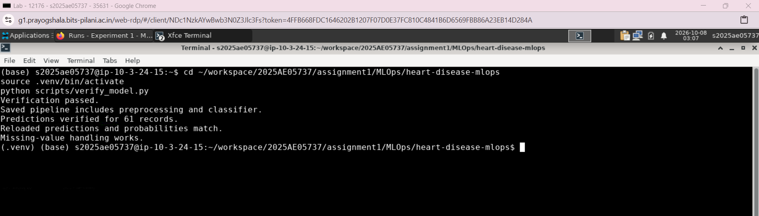

Step 5: Automated Testing and Continuous Integration
Objective
The objective was to validate preprocessing and model behavior through automated tests, check Python code for common errors, and execute the training workflow automatically in a fresh GitHub environment.
5.1 Testing and Linting Tools
We installed two development tools:
Tool | Purpose
Pytest | Execute automated tests and report failures
Ruff | Inspect Python code for common coding errors
Dependencies were captured using:
uv pip install pytest ruff
uv pip freeze > requirements.txt
5.2 Preprocessing Tests
We created tests/test_preprocessing.py with three tests using small synthetic datasets.
Test | What it verifies
Missing-value handling | Missing numeric and categorical values produce finite transformed outputs
Unknown-category handling | An unseen category can be transformed without errors or changing output dimensions
Training-statistic preservation | Transforming new data does not change fitted imputation or scaling statistics
The third test also checks that a missing numeric value is filled using the training median.
We executed:
python -m pytest tests/test_preprocessing.py
Result: 3 tests passed.
These tests validate preprocessing behavior without requiring the downloaded dataset or a saved model.
5.3 Model Tests
We created tests/test_model.py with two tests. A small Random Forest pipeline is fitted on synthetic data to keep testing fast and independent of generated model files.
Test | What it verifies
Prediction validity | Predictions have valid binary labels; probabilities are finite, within [0, 1], and sum to one
Model persistence | Saving and reloading preserves the pipeline, predictions, and probabilities
Inference samples include missing feature values, exercising the preprocessing and classifier together.
We executed:
python -m pytest tests/test_model.py
Result: 2 tests passed.
Together, the project contains five automated tests. These check software behavior and persistence rather than predictive accuracy.
5.4 Python Code Linting
We checked the project’s scripts and tests using:
python -m ruff check scripts tests --select E4,E7,E9,F
The selected rules check import placement, problematic statements, syntax issues, undefined variables, and unused imports.
Ruff initially detected a Seaborn import placed below executable code in scripts/eda.py. We moved the import to the top of the file and reran the check.
Final result:
All checks passed!
5.5 GitHub Actions Workflow
We created the workflow at:
MLOps/.github/workflows/heart-disease-ci.yml
The workflow is stored at the repository root because MLOps contains multiple project folders.
It is configured to run:
- On pushes to main affecting this project or its workflow.
- On pull requests targeting main affecting those paths.
- When started manually from GitHub’s Actions tab.
Path filtering prevents unrelated changes in other projects from triggering this workflow.
5.6 Workflow Execution
The test-and-train job executes on a temporary Ubuntu runner with Python 3.12.
Order | Stage | Purpose
1 | Checkout repository | Obtain the committed project files
2 | Set up Python | Configure Python and dependency caching
3 | Install dependencies | Install requirements.txt and check dependency compatibility
4 | Run Ruff | Detect coding errors
5 | Run Pytest | Execute all five automated tests
6 | Download dataset | Retrieve the UCI Heart Disease data
7 | Prepare data | Generate the training and test partitions
8 | Train baseline models | Compare Logistic Regression and Random Forest
9 | Tune models | Search hyperparameters and save the selected pipeline
10 | Evaluate model | Calculate held-out test metrics and generate plots
11 | Verify pipeline | Check the saved model’s loading and prediction behavior
12 | Upload artifacts | Preserve available model files and reports
Plotting uses the noninteractive Agg backend so figures can be generated without a desktop display.
If a command fails, subsequent normal steps are skipped and the workflow is marked failed. Artifact upload is configured with if: always() so available reports can still be preserved for investigation.
5.7 Reports and Artifacts
The workflow uploads a downloadable artifact bundle containing the generated reports/ and models/ directories.
These include:
- Baseline comparison and fold-level results.
- Complete hyperparameter-search results.
- Tuned-model comparison.
- Held-out test metrics.
- Confusion matrix and ROC curve.
- Pytest results in test-results.xml.
- The fitted pipeline in model.joblib.
Artifacts can be downloaded from:
Repository → Actions → Workflow run → Artifacts
Printed execution output is available by opening the test-and-train job and expanding individual steps.
5.8 MLflow Behavior in CI
Training scripts also create MLflow runs on the GitHub runner. These use the runner’s own tracking database and artifact directory.
They do not appear in the laptop’s MLflow dashboard because it reads a separate local database.
The initial successful workflow uploaded reports and models only. Adding mlflow.db and mlartifacts/ to the upload paths would preserve the CI tracking files in subsequent runs. A shared MLflow server would be required to collect local and CI runs in one tracking service.
5.9 Observed Result
The first GitHub Actions execution completed successfully.
Item | Observed result
Workflow | Heart Disease CI
Trigger | Push to main
Job | test-and-train
Status | Success
Total duration | 2 minutes 5 seconds
Artifact bundles | 1
This demonstrates that the committed project could install dependencies, pass checks, and execute training and evaluation in a fresh GitHub environment.
The workflow summary screenshot provides evidence of successful execution.
Step 5 Outcome
Automated preprocessing and model tests, Python linting, and GitHub Actions CI were implemented successfully.
The workflow validates relevant changes and preserves generated reports and model artifacts. It currently performs checking and training; deployment to higher environments is handled in later steps.

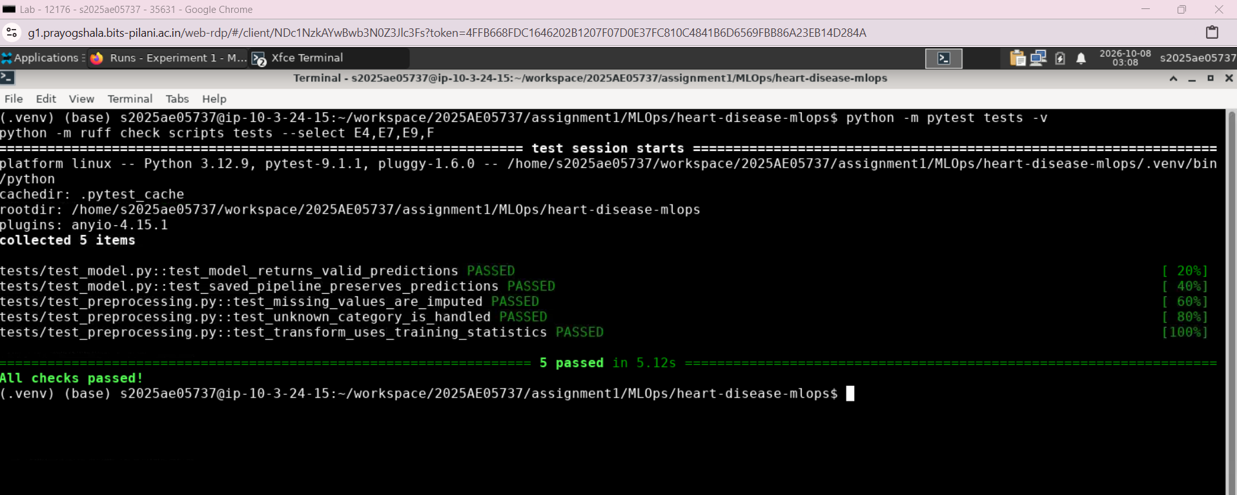

Step 6: Prediction API and Docker Packaging
Objective
The objective was to expose the trained model through a REST API and package the application with Docker so it can run with its dependencies and saved model in a consistent environment.
6.1 API Framework and Setup
We installed FastAPI and Uvicorn:
uv pip install fastapi uvicorn
uv pip freeze > requirements.txt
FastAPI defines the endpoints and validates requests. Uvicorn runs the application.
We created:
app/__init__.py
app/main.py
6.2 Loading the Saved Pipeline
The application loads models/model.joblib once during startup using FastAPI’s lifespan mechanism.
The saved pipeline contains fitted preprocessing and the trained Random Forest classifier. Each request therefore uses the same imputation, encoding, and scaling applied during training.
If the model file is missing, application startup fails with a clear error.
6.3 API Endpoints
Endpoint | Method | Purpose
/health | GET | Return application health status
/predict | POST | Return a prediction and probabilities
/docs | GET | Provide interactive API documentation
The prediction endpoint accepts one record containing the original 13 features.
6.4 Request Validation
A Pydantic request schema validates the input before prediction.
Validation includes:
- All 13 feature fields must be supplied.
- Categorical values must match the supported dataset codes.
- Numeric values must satisfy the defined constraints.
- Extra fields are rejected.
- Infinite and NaN numeric inputs are rejected.
- ca and thal can contain JSON null, which the fitted imputers handle.
The application arranges features in the training column order and converts them to a numeric DataFrame before passing them to the pipeline.
Example request:
{
"age": 63,
"sex": 1,
"cp": 1,
"trestbps": 145,
"chol": 233,
"fbs": 1,
"restecg": 2,
"thalach": 150,
"exang": 0,
"oldpeak": 2.3,
"slope": 3,
"ca": 0,
"thal": 6
}
6.5 Prediction Response
The endpoint returns:
Field | Meaning
prediction | Binary class: 0 for absent, 1 for present
label | Human-readable class label
confidence | Model probability assigned to the predicted class
disease_probability | Model probability assigned to class 1
The application finds probability columns using the classifier’s classes_ attribute.
Observed response during local testing:
{
"prediction": 0,
"label": "Absent",
"confidence": 0.8084166275033862,
"disease_probability": 0.19158337249661375
}
For this input, the model predicted disease absent, assigning approximately 80.84% probability to that class. These values are model estimates.
6.6 Local API Execution
We started the application from the project root:
python -m uvicorn app.main:app --host 127.0.0.1 --port 8000
Interactive documentation was available at:
http://localhost:8000/docs
We submitted the example request through POST /predict and received a valid JSON response.
6.7 Docker Image Definition
We created a Dockerfile in the project root:
FROM python:3.12-slim

WORKDIR /app

ENV PYTHONDONTWRITEBYTECODE=1
ENV PYTHONUNBUFFERED=1

COPY requirements.txt .
RUN python -m pip install --no-cache-dir -r requirements.txt

COPY app/ ./app/
COPY models/model.joblib ./models/model.joblib

EXPOSE 8000

CMD ["python", "-m", "uvicorn", "app.main:app", "--host", "0.0.0.0", "--port", "8000"]
The image contains Python, the dependencies listed in requirements.txt, the API application, and the saved pipeline.
The model is copied into the image during the build. Deploying a different model therefore requires rebuilding the image.
6.8 Build Context Exclusions
We created .dockerignore to exclude unnecessary local files from the build context, including:
- The virtual environment and Python caches.
- Git metadata and .env.
- Testing and linting caches.
- Data and reports.
- MLflow databases and artifact directories.
The saved model remains available for the Dockerfile’s explicit copy operation.
6.9 Image Build and Container Execution
We built the image:
docker build -t heart-disease-api:1.0 .
We then started the container:
docker run -d \
--name heart-disease-api \
-p 127.0.0.1:8001:8000 \
heart-disease-api:1.0
Configuration | Value
Image | heart-disease-api:1.0
Container | heart-disease-api
Container port | 8000
Laptop port | 8001
Published interface | 127.0.0.1
Using laptop port 8001 allowed the containerized API to run alongside the original local API on port 8000.
6.10 Container Verification
The containerized API was accessed at:
http://localhost:8001/docs
The prediction endpoint was reported working successfully. Docker Desktop also showed the container running with port mapping 8001:8000.
For submission evidence, retain:
- A screenshot showing the running container and port mapping.
- A screenshot showing a successful /predict response from port 8001.
Step 6 Outcome
The trained pipeline was exposed through a validated FastAPI prediction endpoint and packaged into a Docker image. Both local API execution and container execution were verified.
The application is ready for the next step: deployment through Kubernetes.
s

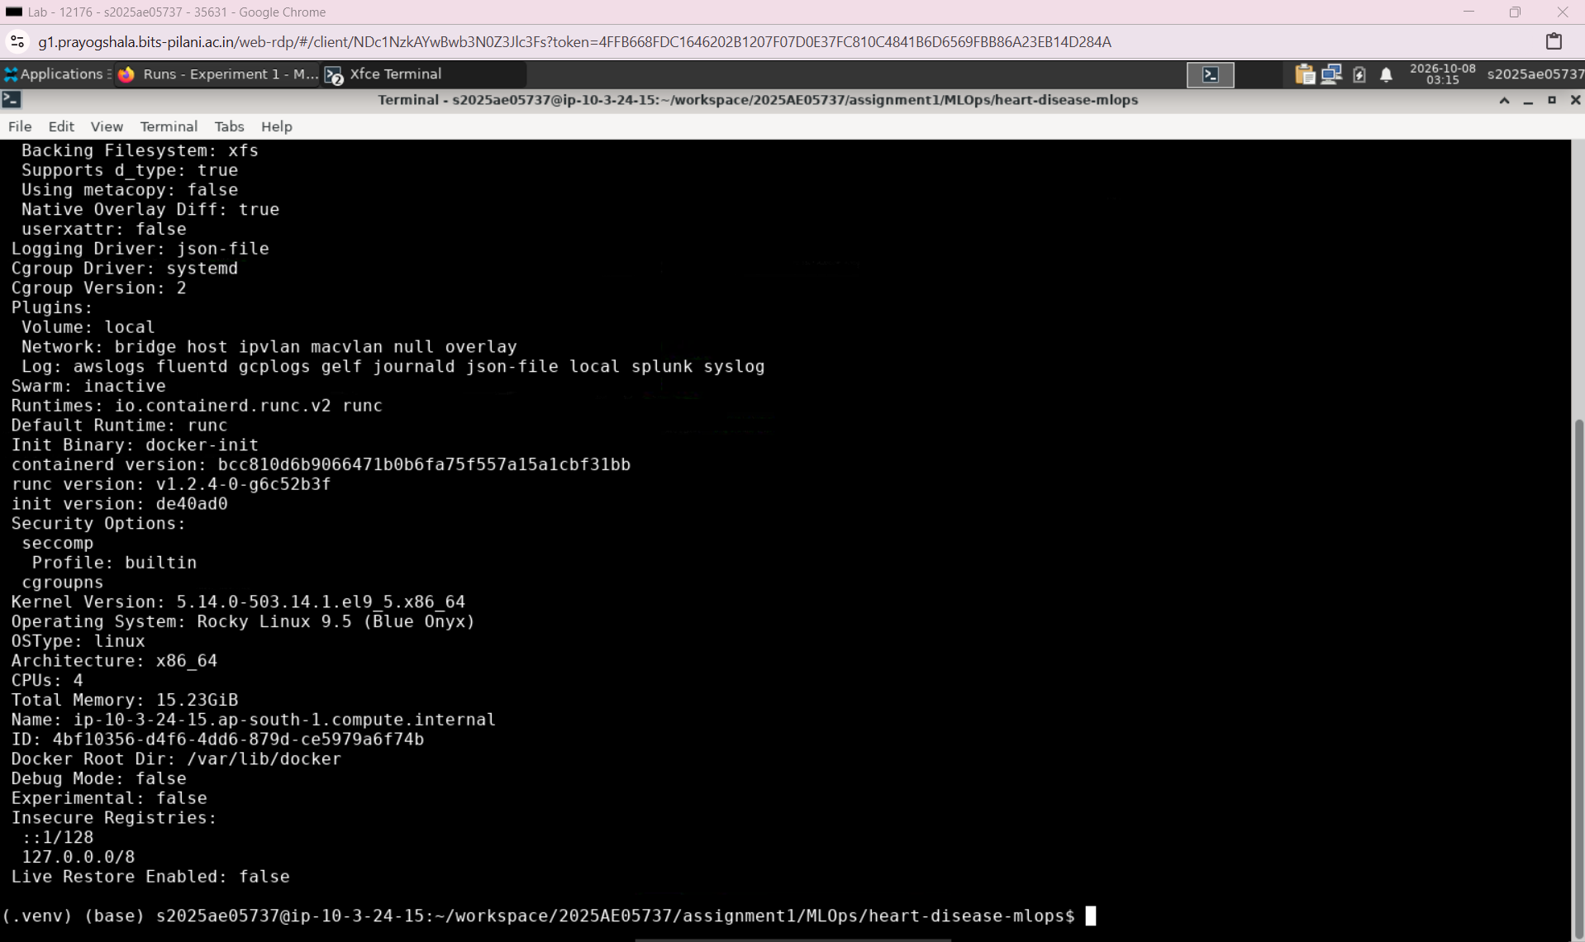

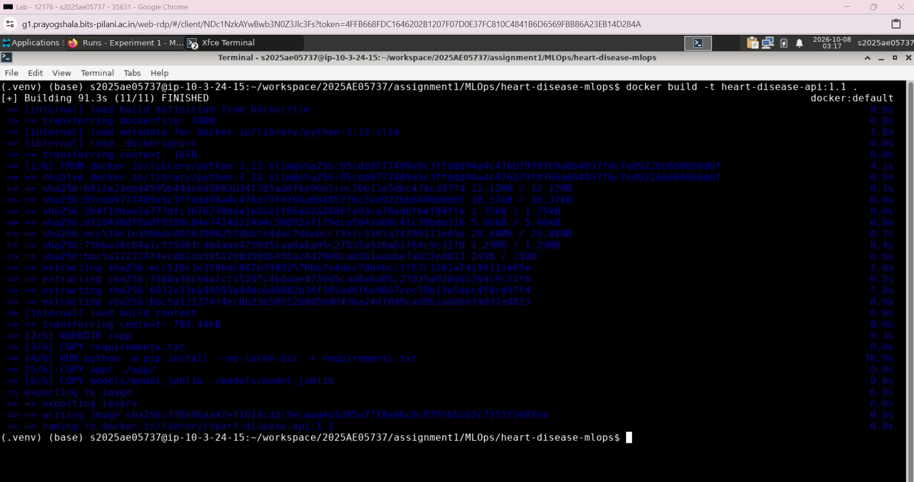

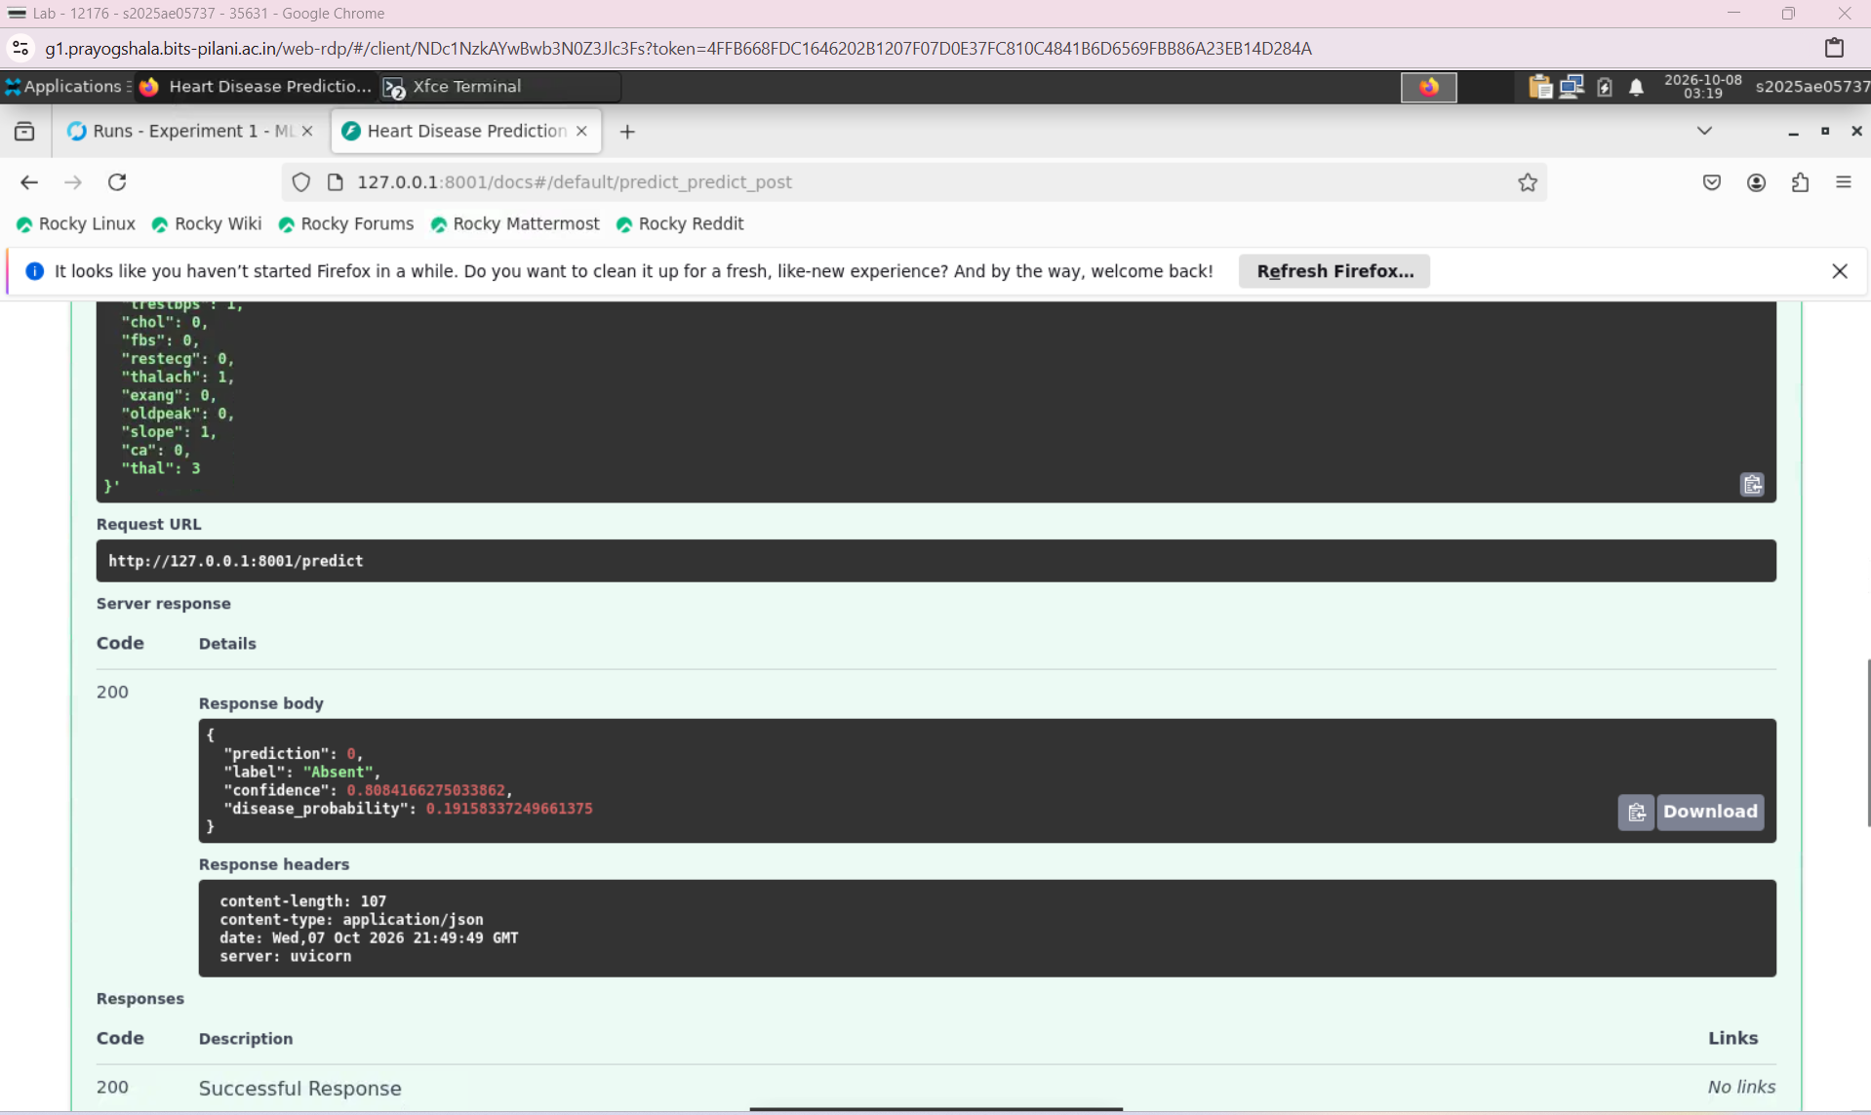

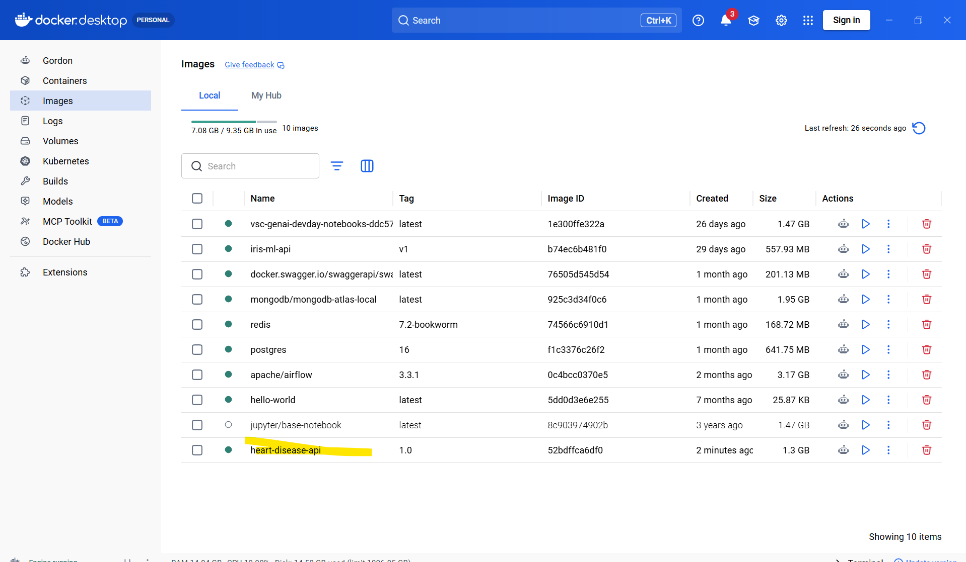

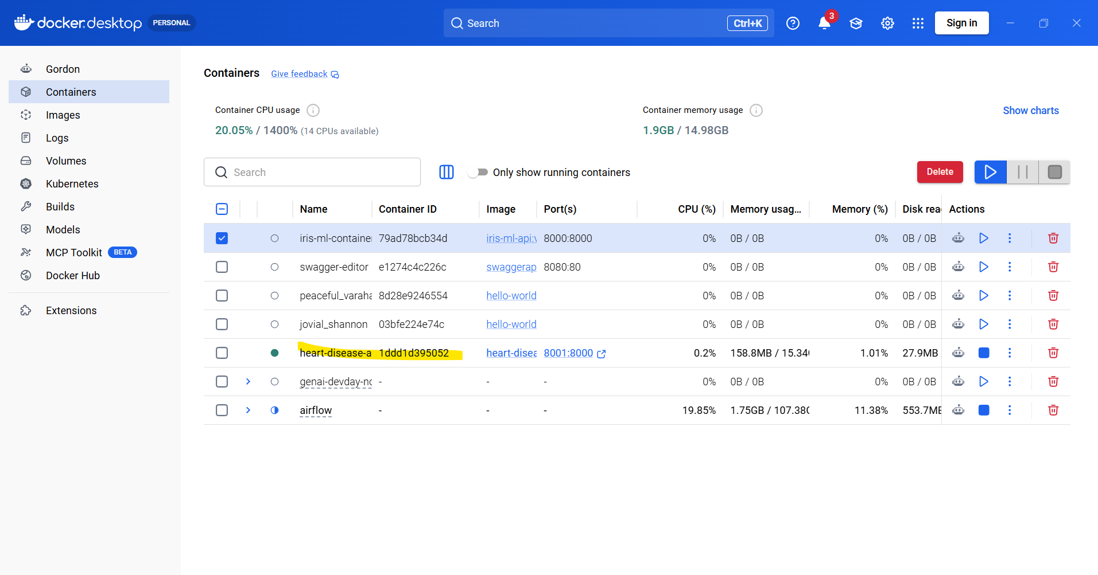

Step 7: Kubernetes Deployment
Objective
The objective was to deploy the containerized prediction API on Kubernetes, configure health checks and resource limits, and expose the application through a Service.
We reused the Docker image created in Step 6. No model retraining was required.
7.1 Local Kubernetes Setup
We enabled Kubernetes in Docker Desktop using the kubeadm provisioner.
The local cluster was checked using:
kubectl --context docker-desktop get nodes
Observed result:
NAME STATUS ROLES VERSION
docker-desktop Ready control-plane v1.36.1
The Ready status confirmed that the node was available to run the application.
7.2 Deployment Configuration
We created k8s/deployment.yaml to define the desired application state.
Setting | Configuration
Deployment name | heart-disease-api
Replicas | 1
Docker image | heart-disease-api:1.0
Image pull policy | Never
Container port | 8000
Application label | app: heart-disease-api
The image pull policy instructs Kubernetes to use the locally available image rather than downloading it from a registry.
The Deployment maintains one application replica and replaces its pod if it fails.
7.3 Resource Requests and Limits
We configured CPU and memory resources:
Resource | Request | Limit
CPU | 100m | 500m
Memory | 256Mi | 512Mi
Requests guide scheduling by specifying the resources the container needs. Limits constrain its resource consumption.
7.4 Application Health Checks
The Deployment uses the API’s /health endpoint for three probes.
Probe | Purpose | Configuration
Startup | Allow the API and model to finish loading | Every 5 seconds; failure threshold 30
Readiness | Determine whether the pod can receive traffic | Every 5 seconds
Liveness | Detect an unresponsive application and trigger restart | Every 10 seconds
The startup probe delays readiness and liveness checks until startup succeeds.
Because the model loads before application startup completes, the health endpoint becomes available after the pipeline has loaded. These probes check application responsiveness; they do not evaluate prediction quality.
7.5 Service Configuration
We created k8s/service.yaml to expose the application.
Setting | Configuration
Service name | heart-disease-api
Service type | LoadBalancer
Service port | 8002
Target container port | 8000
Pod selector | app: heart-disease-api
The Service routes requests to ready pods matching the application label.
Docker Desktop made the API accessible locally at:
http://localhost:8002
Using port 8002 allowed all three execution methods to remain separate:
Execution method | Laptop port
Direct Uvicorn application | 8000
Standalone Docker container | 8001
Kubernetes Service | 8002
7.6 Deployment Execution
We applied both manifests from the project root:
kubectl --context docker-desktop apply -f k8s/
We checked rollout completion and resource status using:
kubectl --context docker-desktop rollout status \
deployment/heart-disease-api --timeout=120s

kubectl --context docker-desktop get deployments,pods,services
Explicitly specifying docker-desktop ensures that these commands target the local cluster.
7.7 Prediction Verification
We opened the interactive documentation at:
http://localhost:8002/docs
We submitted the same sample request used during local and standalone Docker testing.
Observed response:
{
"prediction": 0,
"label": "Absent",
"confidence": 0.8084166275033862,
"disease_probability": 0.19158337249661375
}
The response matched the earlier results, confirming that the Kubernetes deployment served the packaged model successfully.
This demonstrates consistent inference for the tested request across the three execution methods.
7.8 Deployment Evidence
The following screenshots should be retained for submission:
- Kubernetes Deployment, pod, and Service status.
- Successful /predict response through port 8002.
The YAML manifests provide a repeatable description of the deployment. Recreating it on another machine also requires a running cluster and access to the specified Docker image.
Step 7 Outcome
The prediction API was successfully deployed to Docker Desktop Kubernetes using a Deployment and a LoadBalancer Service.
The application has resource requests and limits, startup and health probes, and a working local endpoint. The next step is request logging and monitoring.

Select modelGPT-6.1 SolLightNoneMinimalLightMediumHighExtra HighMaxUltraPersistent

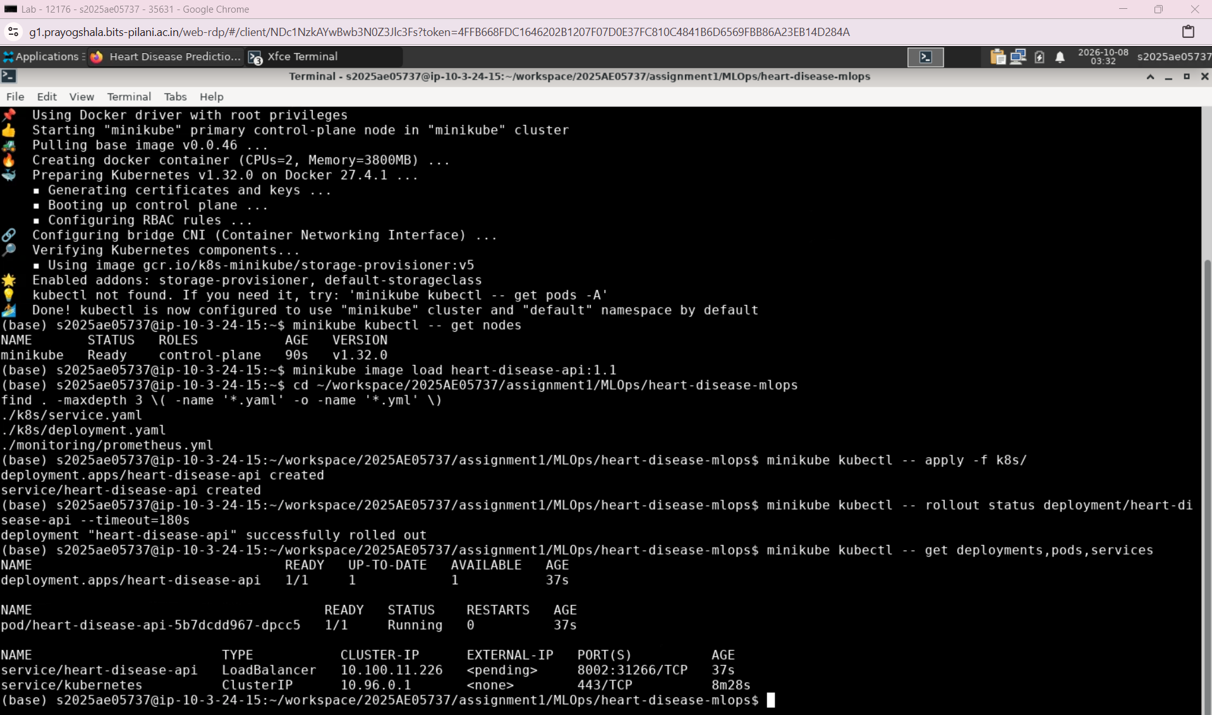

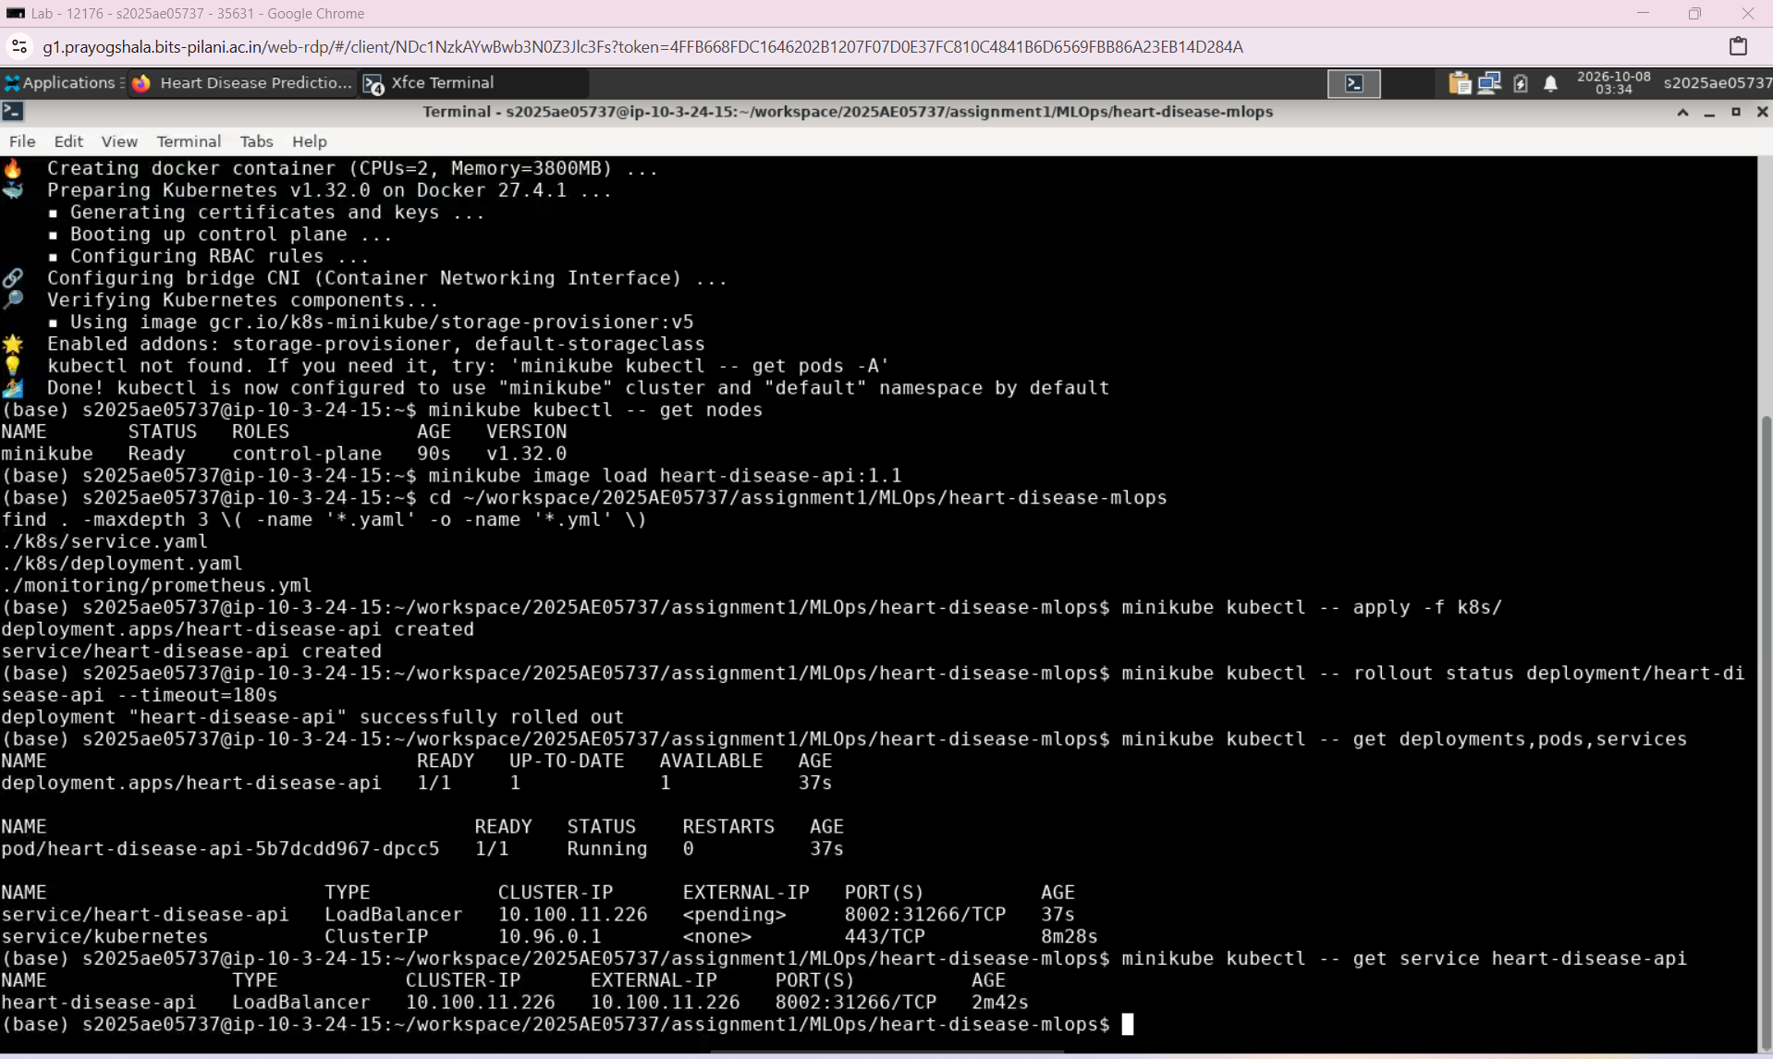

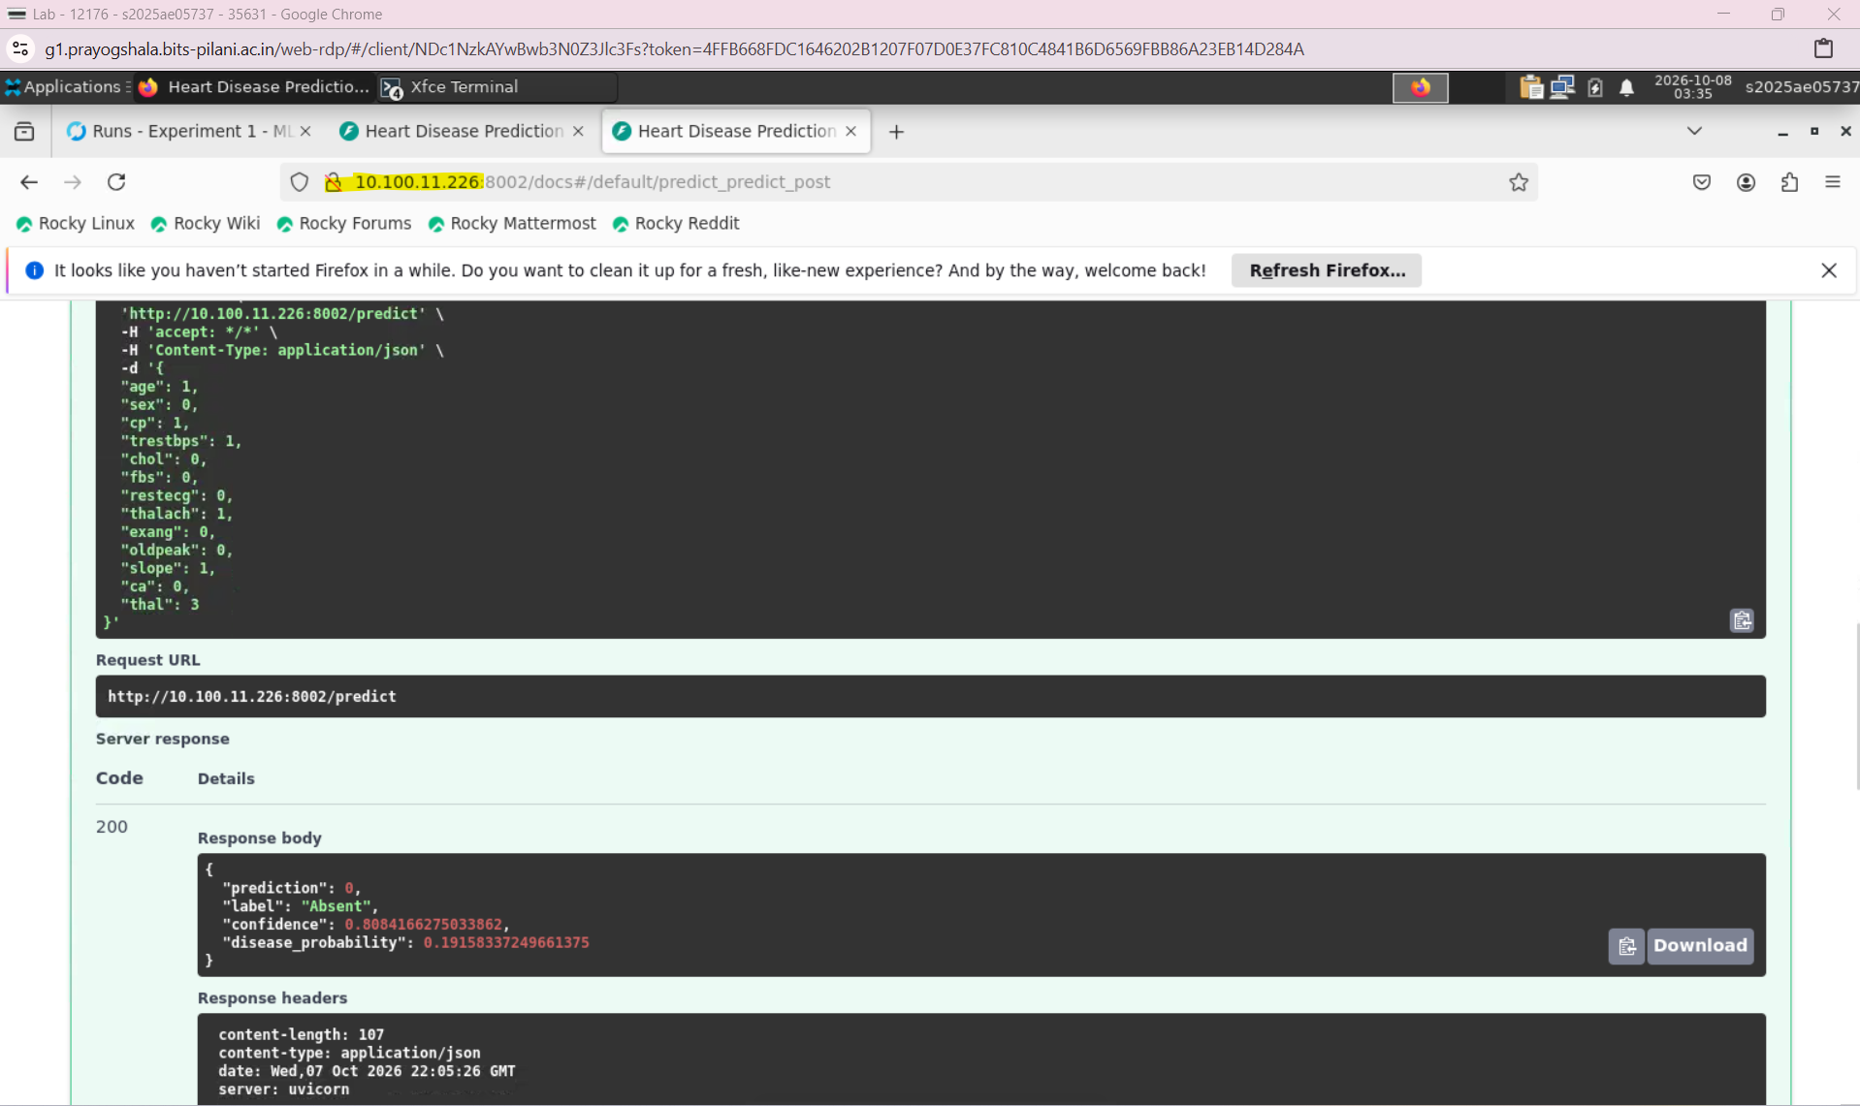

Step 8: API Logging and Monitoring with Prometheus and Grafana
1. Objective
The objective of this step was to monitor the deployed heart disease prediction API and record its request activity. This helps identify service availability issues, failed requests, and changes in response time after deployment.
We implemented:
- Request logging in FastAPI.
- A /metrics endpoint exposing API measurements.
- Prometheus to collect those measurements.
- A Grafana dashboard to visualize API availability, prediction requests, errors, and response time.
2. Request Logging
We added HTTP middleware to the FastAPI application to log each request’s method, path, response status, and processing duration.
An example log entry is:
method=POST path=/predict status=200 duration_ms=182.31
These logs help investigate individual requests and distinguish successful responses from validation failures or application errors. Request payloads are not included in the logs.
3. Exposing API Metrics
We integrated prometheus-fastapi-instrumentator with the FastAPI application:
Instrumentator().instrument(app).expose(app)
This exposes a /metrics endpoint containing measurements such as HTTP request counts and request duration.
The metrics endpoint was verified locally before updating the Kubernetes deployment.
4. Updating the Kubernetes Deployment
We rebuilt the Docker image with the logging and monitoring changes:
docker build -t heart-disease-api:1.1 .
The Kubernetes Deployment was updated to use:
image: heart-disease-api:1.1
After applying the updated manifest and checking the rollout, the API and its metrics endpoint were available through the existing Kubernetes Service:
http://localhost:8002/predict
http://localhost:8002/metrics
5. Configuring Prometheus
We created monitoring/prometheus.yml to configure Prometheus to collect API metrics every 15 seconds:
global:
scrape_interval: 15s

scrape_configs:
- job_name: heart-disease-api
metrics_path: /metrics
static_configs:
- targets:
- host.docker.internal:8002
Prometheus runs in a Docker container and accesses the Kubernetes API through the host’s exposed port. Its web interface is available at:
http://localhost:9090
The target status was verified as UP, confirming that Prometheus could successfully collect metrics from the API.
6. Configuring Grafana
Grafana was deployed in a Docker container and connected to Prometheus through a shared Docker network.
The Prometheus data source URL was configured as:
http://heart-disease-prometheus:9090
Grafana is accessible at:
http://localhost:3000
A dashboard was created to display the following measurements:
Measurement | Purpose
Metrics availability | Confirms that Prometheus can scrape the API
Prediction request count | Shows the number of requests to /predict
Prediction error count | Shows prediction requests returning HTTP 4xx or 5xx responses
Average prediction response time | Tracks the average duration of prediction requests
7. Dashboard Queries
Metrics availability
up{job="heart-disease-api"}
A value of 1 means the latest scrape succeeded; 0 means it failed.
Prediction requests since API start
sum(
http_requests_total{
job="heart-disease-api",
handler="/predict"
}
) or vector(0)
Prediction errors since API start
sum(
http_requests_total{
job="heart-disease-api",
handler="/predict",
status=~"4..|5.."
}
) or vector(0)
This includes input validation failures as well as server errors.
Average prediction response time in milliseconds
1000 *
sum(
rate(http_request_duration_seconds_sum{
job="heart-disease-api",
handler="/predict"
}[5m])
)
/
sum(
rate(http_request_duration_seconds_count{
job="heart-disease-api",
handler="/predict"
}[5m])
)
This calculates the average request duration over the preceding five minutes. It can show no data when there are insufficient recent requests.
8. Validation Results
The completed dashboard showed:
Measurement | Observed result
Metrics availability | 1
Prediction requests | 7
Prediction errors | 0
Average prediction response time | Approximately 80 ms
These observations confirmed that the deployed API was exposing metrics, Prometheus was collecting them, and Grafana was displaying them successfully. The response time is an observation from the demonstration, rather than a load testing benchmark.
Request counters reset when the API process restarts.
9. Files and Artifacts
The monitoring configuration and exported dashboard are maintained within the project:
monitoring/prometheus.yml
monitoring/grafana-dashboard.json
The dashboard JSON allows the dashboard to be imported into another Grafana instance. Docker volumes preserve Prometheus data and Grafana configuration when containers are recreated using the same volumes.
The implementation also updated:
- app/main.py — request logging and metrics instrumentation.
- requirements.txt — monitoring dependency.
- k8s/deployment.yaml — updated API image version.
10. Outcome
Step 8 added operational visibility to the deployed prediction service. Request logs support troubleshooting individual API calls, while Prometheus and Grafana provide a continuously updated view of availability, traffic, errors, and response time.
The monitoring covers API behavior; model accuracy and data drift monitoring were not implemented in this step.

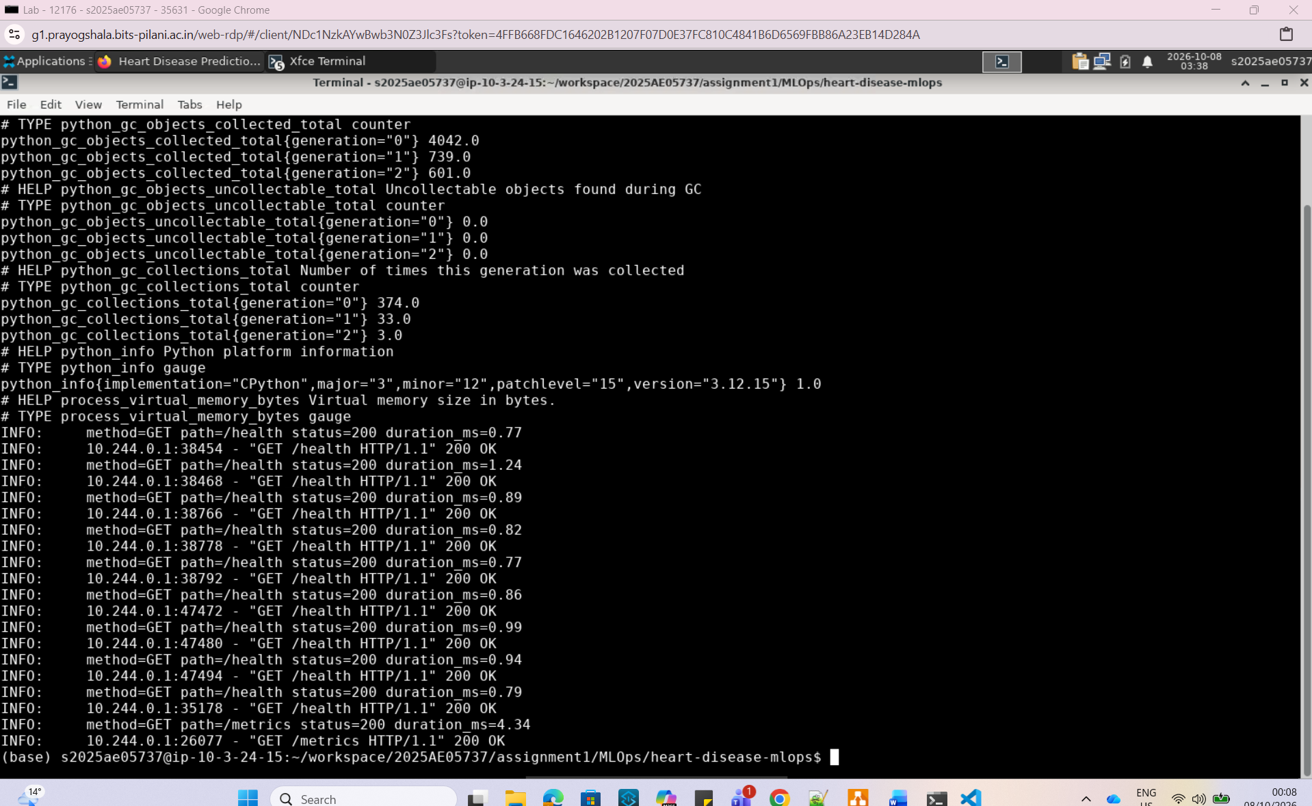

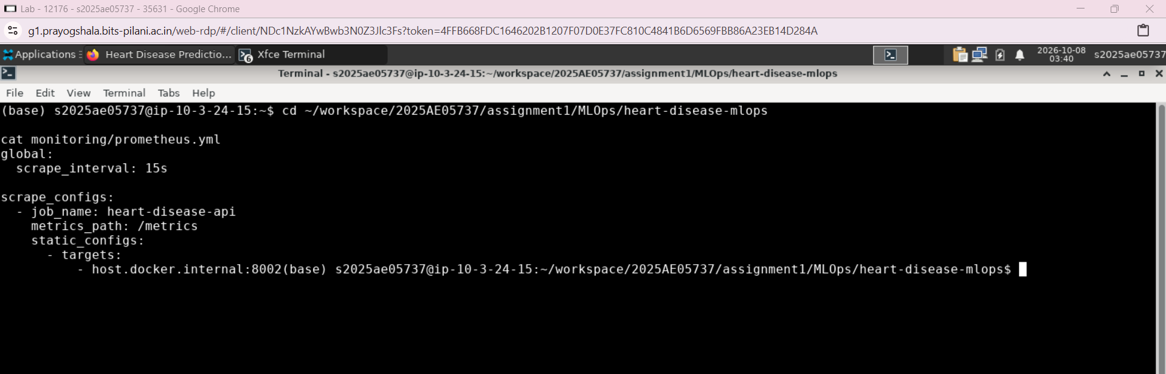

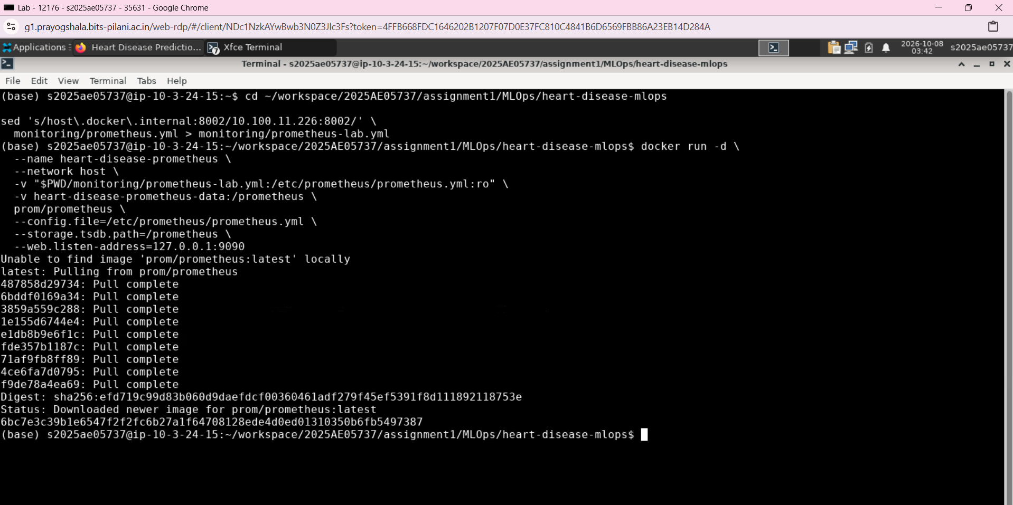

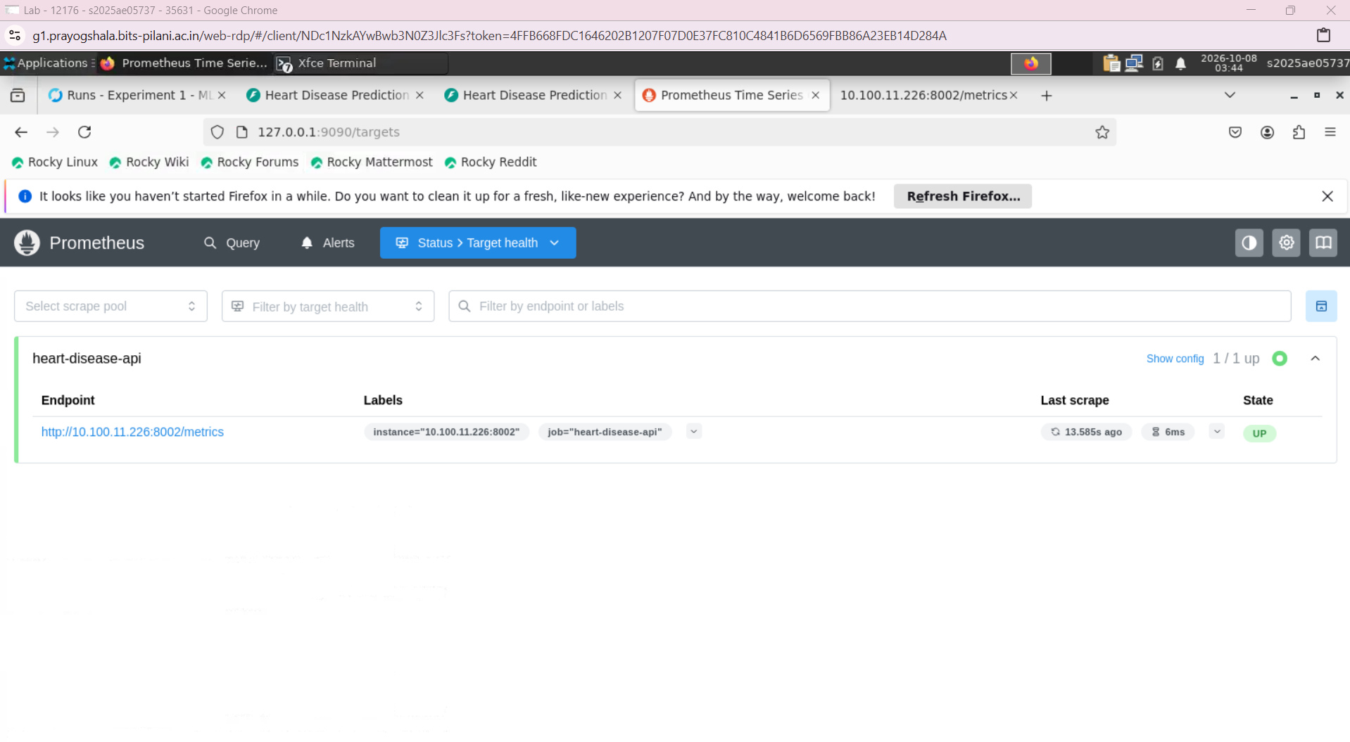

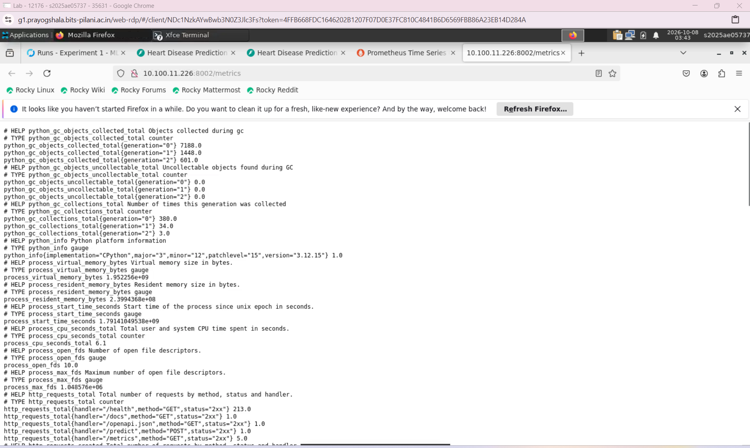

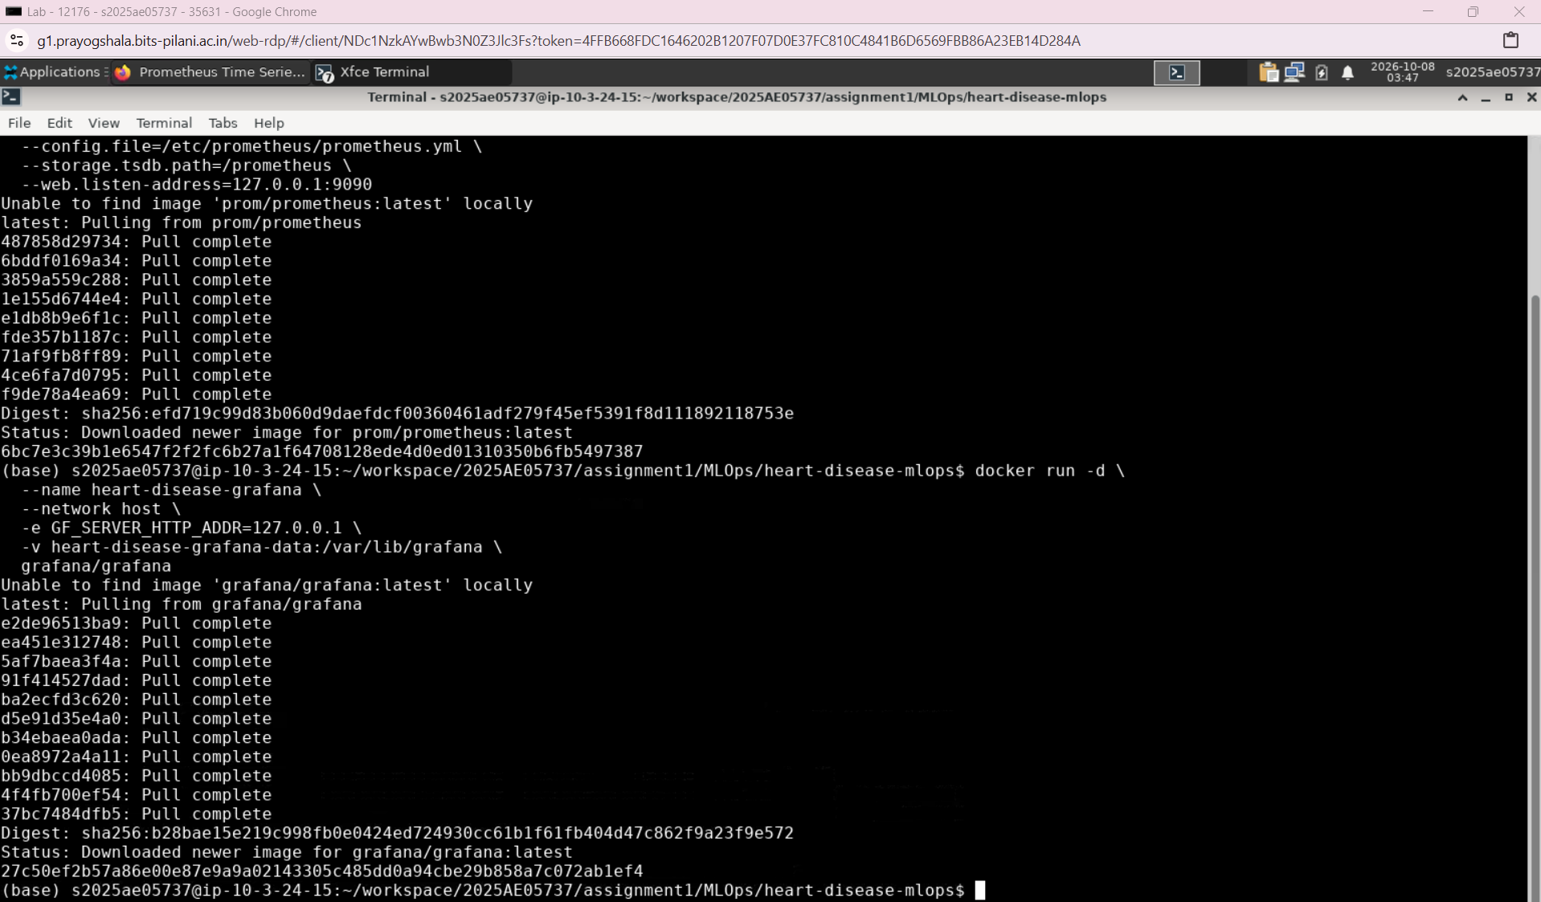
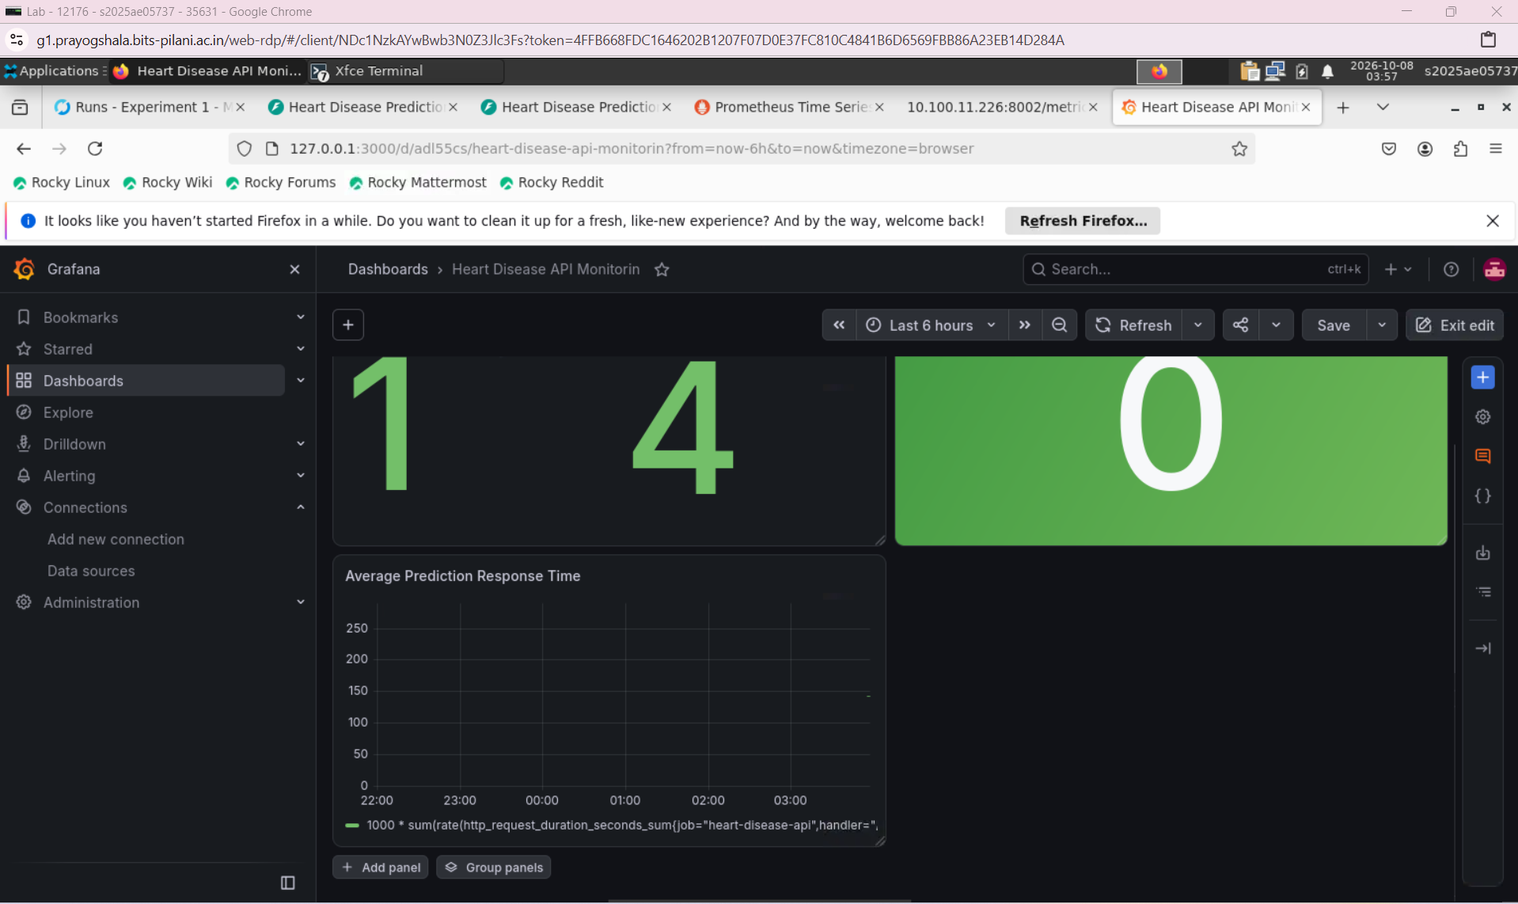

LAB Envionment :

